1-Page Summary Report: Bayesian Hypothesis Testing Approaches

Problem Statement
After completing a classical (frequentist) analysis of the Familiar Vein and Artery Pack lifespan data, the organisation needs complementary Bayesian answers that speak directly in probabilities: What is the probability that the Vein Pack mean exceeds the 71-year population benchmark? What is the probability that Vein is superior to Artery? How sensitive are these conclusions to prior assumptions? These questions are more natural for product and executive audiences than p-values.

Solution Strategy
1. Contrast frequentist and Bayesian decision language.
2. Demonstrate the Beta-Binomial conjugate model on a classic A/B conversion experiment.
3. Place a flat prior on the mean lifespan and obtain the exact Student-t posterior; answer P(μ > 71) and P(Vein > Artery) by Monte-Carlo.
4. Compute 95 % Highest Density Intervals and a ROPE analysis.
5. Provide alternate implementations (analytic Beta quantiles, prior sensitivity, bootstrap posterior).
6. Run a simulation that varies sample size and prior strength so the team can see how the posterior probability behaves under different designs.
7. Translate every key result into executive, product and technical language following the supplied audience-analysis guidelines.

Solution
Beta-Binomial A/B illustration (1 200 visitors per arm, 10 % vs 13 % conversion): P(treatment > control | data) ≈ 0.99 under a uniform prior; expected absolute lift ≈ 0.03.
Familiar lifespan (Bayesian t-posterior under flat prior):
• P(μ_Vein > 71 | data) ≈ 1.00
• P(μ_Vein > μ_Artery | data) ≈ 0.97
• Vein 95 % HDI ≈ [75.25, 77.06] years
• Difference 95 % HDI still includes a small negative value, consistent with the classical p ≈ 0.056
• Under a ±0.5-year ROPE the majority of posterior mass lies above the ROPE, supporting practical superiority of Vein.
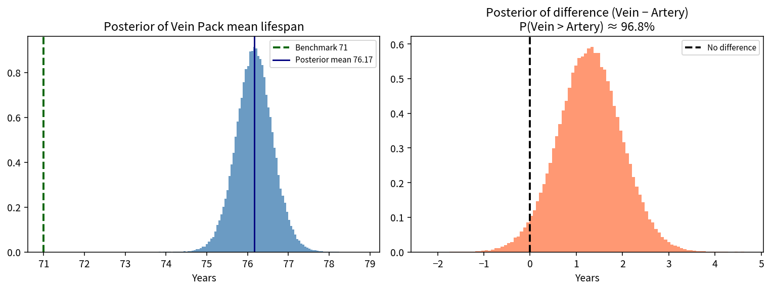
Posterior of Vein mean and of the Vein−Artery difference

Key Takeaways
1. Bayesian methods answer the probability questions stakeholders actually ask and are therefore easier to communicate.
2. For the Vein Pack versus the 71-year benchmark the posterior probability is essentially 1 — the claim can be made with high confidence.
3. For Vein versus Artery the probability of superiority is high (≈ 0.97) yet the credible interval still touches zero; a larger sample or a carefully justified ROPE is needed before absolute marketing language is used.
4. Always report prior sensitivity; decisions that flip under a reasonable skeptical prior should be flagged.
5. The same simulation framework used for frequentist power can be repurposed to estimate how often a Bayesian decision threshold (e.g. P > 0.95) will be reached under a true lift.

